H.T No
Regulations:
A17

Sreenidhi Institute of Science and Technology
(An Autonomous Institution)
Code No: 6K704 Date: 08-July-2021(AN)

B.Tech IV-Year I- Semester Pending External Examination, July - 2021 (Regular)
FINITE ELEMENT METHOD FOR CIVIL ENGINEERS (CIVIL)

Time: 3 Hours Max.Marks:75

Note: a) No additional answer sheets will be provided.
b) All sub-parts of a question must be answered at one place only, otherwise it will not be valued.
c) Missing data can be assumed suitably.

ANSWER ANY 5 OUT OF 8 QUESTIONS. EACH QUESTION CARRIES 15 MARKS.

Bloom's Cognitive Levels of Learning (BCLL)

Remember | L1 | Apply | L3 | Evaluate | L5
Understand | L2 | Analyze | L4 | Create | L6

 |  |  | BCLL | CO(s) | Marks
1. | a) | By using stress strain relations derive the D matrix for three-dimensional case. | L3 | CO1 | [8M]
 | b) | Derive the expression to calculate the maximum deflection in a beam of length L with a point load P acting at the center by using Rayleigh Ritz method. Take | L4 | CO1 | [7M]
2. | a) | Discuss how penalty approach is used in handling specified displacement boundary conditions. [8] | L2 | CO2 | [8M]
 | b) | In the fig.1 shown, A load P = 60 X 10³ N is applied. Determine the displacement field, stress, and support reactions in the body. Take E = 20 X 10³ N/mm².  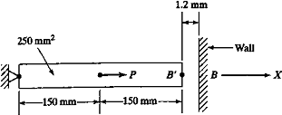  Fig.1 | L5 | CO2 | [7M]
3. | a) | Derive the strain displacement matrix of a constant strain triangle element. | L5 | CO3 | [8M]
 | b) | For the triangular element shown in the fig.2 obtain the strain – displacement relation matrix and determine the strains ꝺx , ꝺy and ꝺxy .  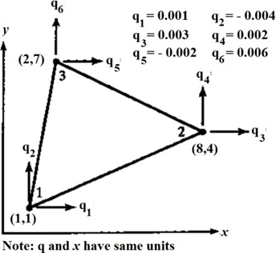  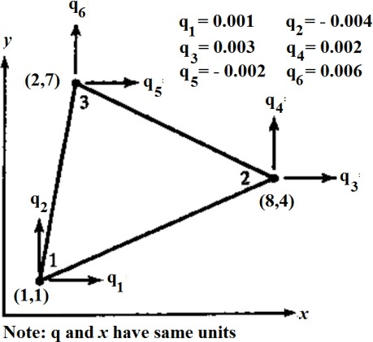  Fig.2 | L5 | CO3 | [7M]
4. | a) | Derive the stiffness matrix of one-dimension quadratic element. | L5 | CO4 | [8M]
 | b) | Discuss about the Isoperimetric, sub parametric and super parametric elements | L2 | CO4 | [7M]
5. | a) | Determine the Eigen values and Eigen vectors of the bar shown in fig.3. Take E=200 GPa, ρ = 2800 kg/m³, A=0.258 m², and L=0.4 m  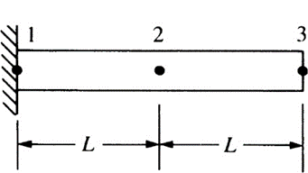  Fig.3 | L5 | CO5 | [8M]
 | b) | Write short answers on the following.  - Numerical integration  - Static condensation  - Geo-metric invariance  - Boundary conditions | L1 | CO5 | [7M]
6. | a) | What are the steps involved in FEA using ANSYS? | L1 | CO6 | [8M]
 | b) | Why ANSYS Software is used for ? | L2 | CO6 | [7M]
7. | a) | Derive the equilibrium equations at any point in 2-Dimensional elastic systems under the action of external forces, in terms of stresses. | L6 | CO1 | [5M]
 | b) | Discuss the equilibrium equations and strain displacement relationship. If a displacement field is described by u=50x²j+40xy+7y² and v=j10x²+25xyj+12y². Determine E_{x} ; E_{y}: O_{xy} at point (2,-2). | L5 | CO2 | [5M]
 | c) | What do you mean by shape functions and derive shape functions for a simple bar element? | L2 | CO3 | [5M]
8. | a) | What are convergence requirements in the context of displacement model, and explain their significance | L2 | CO4 | [5M]
 | b) | Derive shape functions of a simple rectangular element in terms of iso-parametric element. | L6 | CO5 | [5M]
 | c) | What are the different types of elements that are used in ANSYS software? | L2 | CO6 | [5M]

-- 00 -- 00 –

